|  |
| --- |
| Progress Report / Status Report |

Monthly Report Intern Matteo De Benedetti - September 2019

Approval

|  |  |
| --- | --- |
| Title Monthly Report Intern Matteo De Benedetti - September 2019 | |
| Issue Number 1 | Revision Number 0 |
| Author Matteo De Benedetti | Date 03/10/2019 |
| Approved By | Date of Approval |
|  |  |

Change Log

|  |  |  |  |
| --- | --- | --- | --- |
| Reason for change | Issue Nr. | Revision Number | Date |
| Creation of Document | 1 |  | 03/10/2019 |

Change Record

|  |  |  |  |
| --- | --- | --- | --- |
| Issue Number  1 | Revision Number  0 | | |
| Reason for change | Date | Pages | Paragraph(s) |
| Creation of Document | 03/10/2019 | All | All |

Distribution

|  |
| --- |
| Name/Organisational Unit |
| Martin Azkarate, TEC-MMA, ESA-ESTEC |
| Mario Innocenti, Robotics and Automation Engineering, University of Pisa |

Table of contents:

1 Introduction 4

1.1 Scope of the Document 4

1.2 European Space Agency 4

1.3 Section 6

1.4 Planetary Robotics Laboratory 6

2 internship activities 8

2.1 Tasks Definition 8

3 september activities 9

3.1 1st Week: 02/09/2019 – 06/09/2019 9

3.2 2nd Week 09/09/2019 – 13/09/2019 10

3.3 3rd Week: 16/09/2019 – 20/09/2019 10

3.4 4th Week: 23/09/2019 – 27/09/2019 13

4 References 17

4.1 Reference documents 17

4.2 List of Acronyms 17

4.3 Table of Figures 17

# Introduction

## Scope of the Document

This document reports the work done by the author, Matteo De Benedetti, during his first month of work as an intern at the European Space Research and Technology Centre (ESTEC).

## European Space Agency

The European Space Agency (ESA) is Europe’s gateway to space. Its mission is to shape the development of Europe’s space capability and ensure that investment in space continues to deliver benefits to the citizens of Europe and the world.

ESA is an international organisation with 22 Member States. By coordinating the financial and intellectual resources of its members, it can undertake programmes and activities far beyond the scope of any single European country.

**ESA Activities:**

ESA’s job is to draw up the European space programme and carry it through. ESA's programmes are designed to find out more about Earth, its immediate space environment, our Solar System and the Universe, as well as to develop satellite-based technologies and services, and to promote European industries. ESA also works closely with space organisations outside Europe.

**ESA States:**

Austria, Belgium, Czech Republic, Denmark, Estonia, Finland, France, Germany, Greece, Hungary, Ireland, Italy, Luxembourg, the Netherlands, Norway, Poland, Portugal, Romania, Spain, Sweden, Switzerland and the United Kingdom. Slovenia is an Associate Member. Canada takes part in some projects under a cooperation agreement.

Bulgaria, Croatia, Cyprus, Malta, Latvia, Lithuania and Slovakia have cooperation agreements with ESA.

**ESA Locations:**

ESA's headquarters are in Paris which is where policies and programmes are decided. ESA also has sites in a number of European countries, each of which has different responsibilities:

* EAC, the European Astronauts Centre in Cologne, Germany;
* ESAC, the European Space Astronomy Centre, in Villanueva de la Canada, Madrid, Spain;
* ESOC, the European Space Operations Centre in Darmstadt, Germany;
* ESRIN, the ESA centre for Earth Observation, in Frascati, near Rome, Italy;
* ESTEC, the European Space Research and Technology Centre, Noordwijk, the Netherlands.
* ECSAT, the European Centre for Space Applications and Telecommunications, Harwell, Oxfordshire, United Kingdom.
* ESEC, the European space Security and Education Centre, Redu, Belgium.

ESA also has liaison offices in Belgium, USA and Russia; a launch base in French Guiana and ground/tracking stations in various parts of the world.

**European Space Research and Technology Centre (ESTEC):**

ESA has sites in several European countries, but the European Space Research and Technology Centre (ESTEC) in Noordwijk, the Netherlands, is the largest. ESTEC is our technical heart - the incubator of the European space effort - where most ESA projects are born and where they are guided through the various phases of development.

* Developing and managing all types of ESA missions: science, exploration, telecommunications, human spaceflight, satellite navigation and Earth observation.
* Providing all the managerial and technical competences and facilities needed to initiate and manage the development of space systems and technologies.
* Operating an environmental test centre for spacecraft, with supporting engineering laboratories specialised in systems engineering, components and materials, and working within a network of other facilities and laboratories.
* Supporting European space industry and working closely with other organisations, such as universities, research institutes and national agencies from ESA Member States, and cooperating with space agencies all over the world.



Figure 1: ESTEC

## Section

I am working in the TEC-MMA, the Automation & Robotics Section of the Mechatronics & Optics Division (TEC-MM) that is part of the Mechanical Department (TEC-M).



Figure 2: Mechanical Department Organization

## Planetary Robotics Laboratory

Specifically, I work in the Planetary Robotics Lab (PRL), located in the Erasmus building, under the supervision of Martin Azkarate.

The ESA Planetary Robotics Laboratory is an engineering research laboratory that specialises in addressing the challenges robot probes face in the exploration of the surface of Moon and Mars, with particular attention to the motion aspect.

As a probe moves on a far planetary surface it must have physical locomotion ability, navigation ability and logical autonomy. The lab is equipped to study and support research, development, validation and verification of all three aspects.

Of particular interest is the Mars Analogue Terrain, a square 9m by 9m terrain ‘sandbox’ filled with different sizes of sand, gravel and rock designed according to models of a Martian terrain. It is equipped with a fixed installation of a motion capture measurement system, the VICON Motion Capture Camera System that provides ground truth localisation data of the subjects tracked, which can be a rover body pose or positioning of sensor subsystems or interfacing structures.

The terrain is used for initial prototype testing and debugging of algorithms and as means of maturing technology to be later tested in more representative environments.

Rover prototypes, such as ExoTer, are tested in the Mars yard to demonstrate locomotion or navigation capabilities over a planetary surface of different terrain characteristics.

The ExoTer Rover, ExoMars Testing Rover is a half-scale reproduction of the ExoMars rover that mimics the locomotion and navigation subsystems of the real rover.

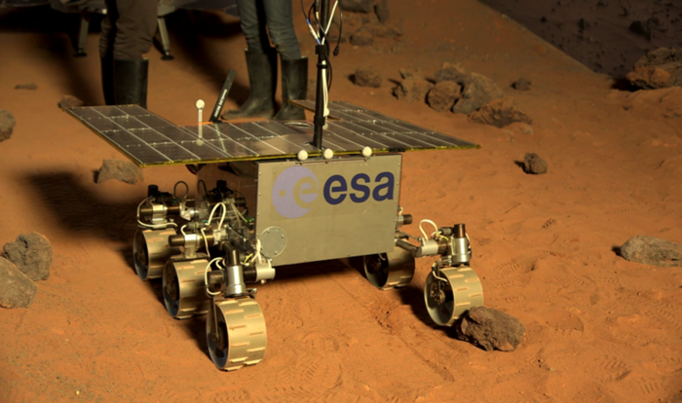

Figure 3: ExoTer Rover

# internship activities

At my arrival at ESTEC I carried out all the necessary administrative tasks, such as office assignment, work laptop setup and security badge delivery.

After that I attended three briefings:

* Newcomers Briefing: to explain the main ESTEC’s rules and the main safety behaviours
* Automation and Robotics Laboratories Tour: My supervisor Martin Azkarate gave me a tour of the 2 main laboratories of the section, the Planetary Robotics Laboratory and the Orbital Robotics Laboratory, explaining and showing the main activities that are carried out there.
* ARL safety briefing: to explain the safety and operational aspects of the laboratories and to be aware of the risks that exist when working in laboratory.

## Tasks Definition

With my supervisor Martin Azkarate a list of tasks to be performed during the internship and the main aim of my work has been defined.

1. Familiarization with the ROCK framework [RD03] used in the rover prototypes of the PRL.
2. Training on how the scripts and libraries are organized in bundles in the on-board rover computers
3. Training on the operations of the ExoTer Rover:
   1. Powering on and off the rover.
   2. Connection to the rover via the workstation or ssh from a lab laptop.
   3. Deployment and execution of a script on the ExoTer Rover.
   4. Usage the Vicon Tracker system.
4. Study the Visual Odometry script [RD01]:
   1. Get familiar with the architecture of the script and libraries it relies on [RD04].
   2. Learn to modify part of the scripts, call different tasks and use the configuration files.
   3. Log data, replay them and export to a .txt file for post-processing and further analysis.
   4. Analyse the performances of the algorithm and define the data of interest to be logged.
5. Perform a series of tests to see how different parameters affect the Visual Odometry performances:
   1. Define the parameters of interest to be changed, considering the Scenario of the Mars Sample Return Mission.
   2. Run the tests.
   3. Visualize and analyse the results
6. If time allows it, investigate possible improvements of the existing Visual Odometry algorithm.

# september activities

During the first Month I worked on tasks 1-2-3-4.

## 1st Week: 02/09/2019 – 06/09/2019

Initially I read the ROCK documentations and went through the basics and advanced tutorials available on the ROCK website (<https://www.rock-robotics.org/>).

Rock is a software framework for the development of robotic systems. The underlying component model is based on the Orocos RTT (Real Time Toolkit).

ROCK relies on *libraries* written in C++ that only provide the functionality, they are integrated in *components* that can be connected together as *Orogen components*, and finally executed and configured with a ruby script.

This architecture, as long as all the functionality is contained in the C++ library and the Orogen components is as slim as possible, helps to separate functionality from integration.

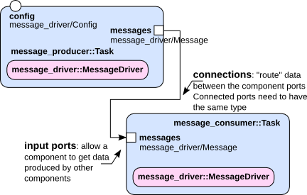

Figure 4: ROCK Components

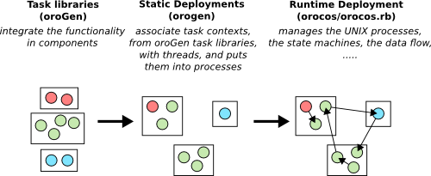

Figure 5: ROCK Architecture

Then I have been tutored by a colleague, Tim Wiese, on how to operate ExoTer, in order to be able to autonomously work on the rover.

I was taught how to power on and off the rover, how the power supply works and how the rover is connected to it.

He also showed me the main hardware components and quickly explained how they are connected together.

He illustrated the organization of the code in *bundles* and the tasks *deployments.*

Then he guided me through the launch of a script, how the rover is controlled with the joystick and how the Vicon system tracks its pose.

## 2nd Week 09/09/2019 – 13/09/2019

After some fixes and improvements for the logging, a simple test to evaluate the Visual Odometry script was performed and then a Matlab script [RD02] was written to visualize the results.

It was decided to start by analysing the following aspects of the experiment:

* The planar trajectory of the rover estimated by the VO against the ground truth trajectory measured by the Vicon System.
* The error norm of the X and Y components of the trajectory, computer as following: *error = ground truth – VO estimation*.

The results obtained are reported below and show that the VO algorithm correctly tried to estimate the rover pose, though the accuracy could, and should, be improved.



## 3rd Week: 16/09/2019 – 20/09/2019

During the third week the focus was on improving the Visual Odometry script to perform the tests.

Initially the rover was controlled with a joystick, which made very hard to send the same control signal to the rover across multiple tests.

With this in mind, it was decided to implement the possibility of recording a sequence of controls with the joystick and then be able to use it in the tests [RD01].

Using a recorded sequence with the joystick helped improving the consistency across multiple tests and also is better than hard-coding a sequence of control signals because it allows to visualize the trajectory of the rover and what the cameras captures.

Using the newly implemented feature a first sequence of tests was performed.

Three control sequences were produced to move the rover straight for 3 meters only varying the translational speed:

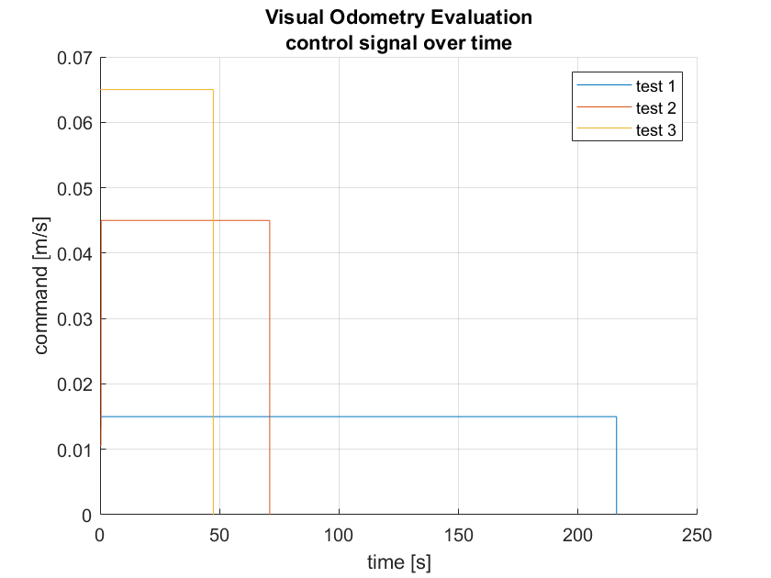

|  |  |
| --- | --- |
| Test | Control |
| [Test 1] | translational velocity = 0.015 m/s |
| [Test 2] | translational velocity = 0.045 m/s |
| [Test 3] | translational velocity = 0.065 m/s |

The following results were obtained:

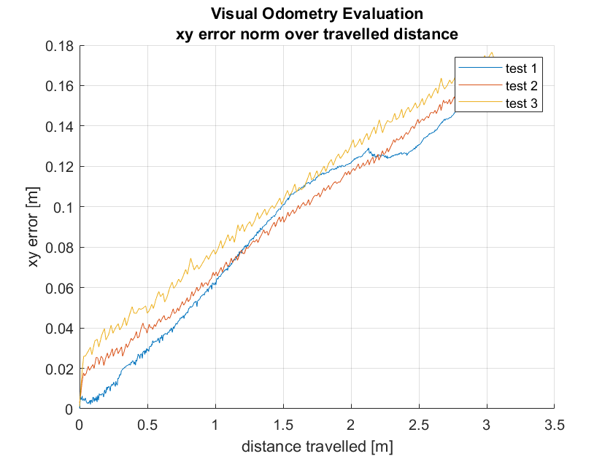

The results show that, with automatic exposure time, the translational velocity does not seem to be affecting the VO estimation error that grows at the same rate in all three cases.

It is also important to see that there is clearly a relevant error in the first step of the VO algorithm.

This has been further investigated with other tests and it has been observed that, almost on every occasion, the first iteration fails and does not converge, resulting in a big error at the very beginning that cannot be recovered.

This leads to relatively large errors (around 5% of the travelled distance) compared to the current state of the art (2% error of the travelled distance)

Further tests have also shown a possible correlation between the direction of movement and the error in the pose estimated by the VO.

This, in combination with a significant drift on the z axis, both shown in the pictures below, suggest a possible miscalibration of the camera.

Also, from a visual inspection of the rover, the camera bracket seems unstable, in particular the pitch angle. This may also contribute to error in the VO estimate.

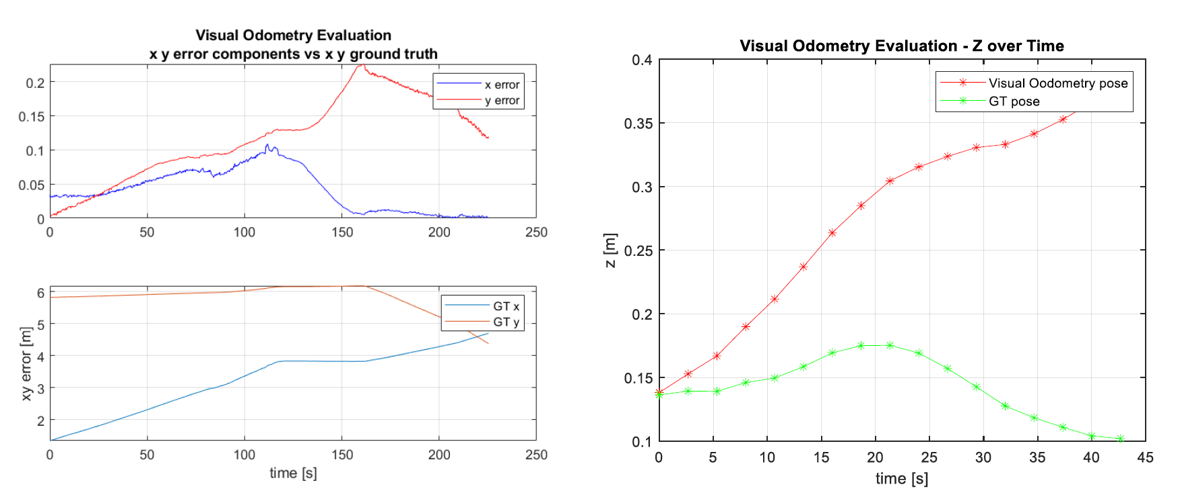

Figure 6: pose estimation error and z component drift

## 4th Week: 23/09/2019 – 27/09/2019

A new camera bracket was designed in Solidworks and printed with one of the 3D printer available in the lab (Ultimaker 3 Extended) and then mounted on the ExoTer Rover.

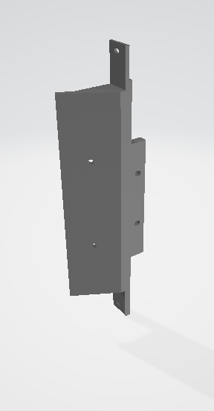

Figure 7: New camera bracket

The design is inspired to the previous one, with the addition of a reinforcement on the top to avoid it would break again and to make it stronger and sturdier.

The new camera bracket and the error seen so far in the VO made it necessary to compute again the transformation from the body reference frame (placed on the lower plate of the body, in the midpoint of the axis between the two middle wheels) to the left camera reference frame (placed in the left camera with xy on the usual image plane and z pointing forward), with particular care to the pitch angle of the camera.

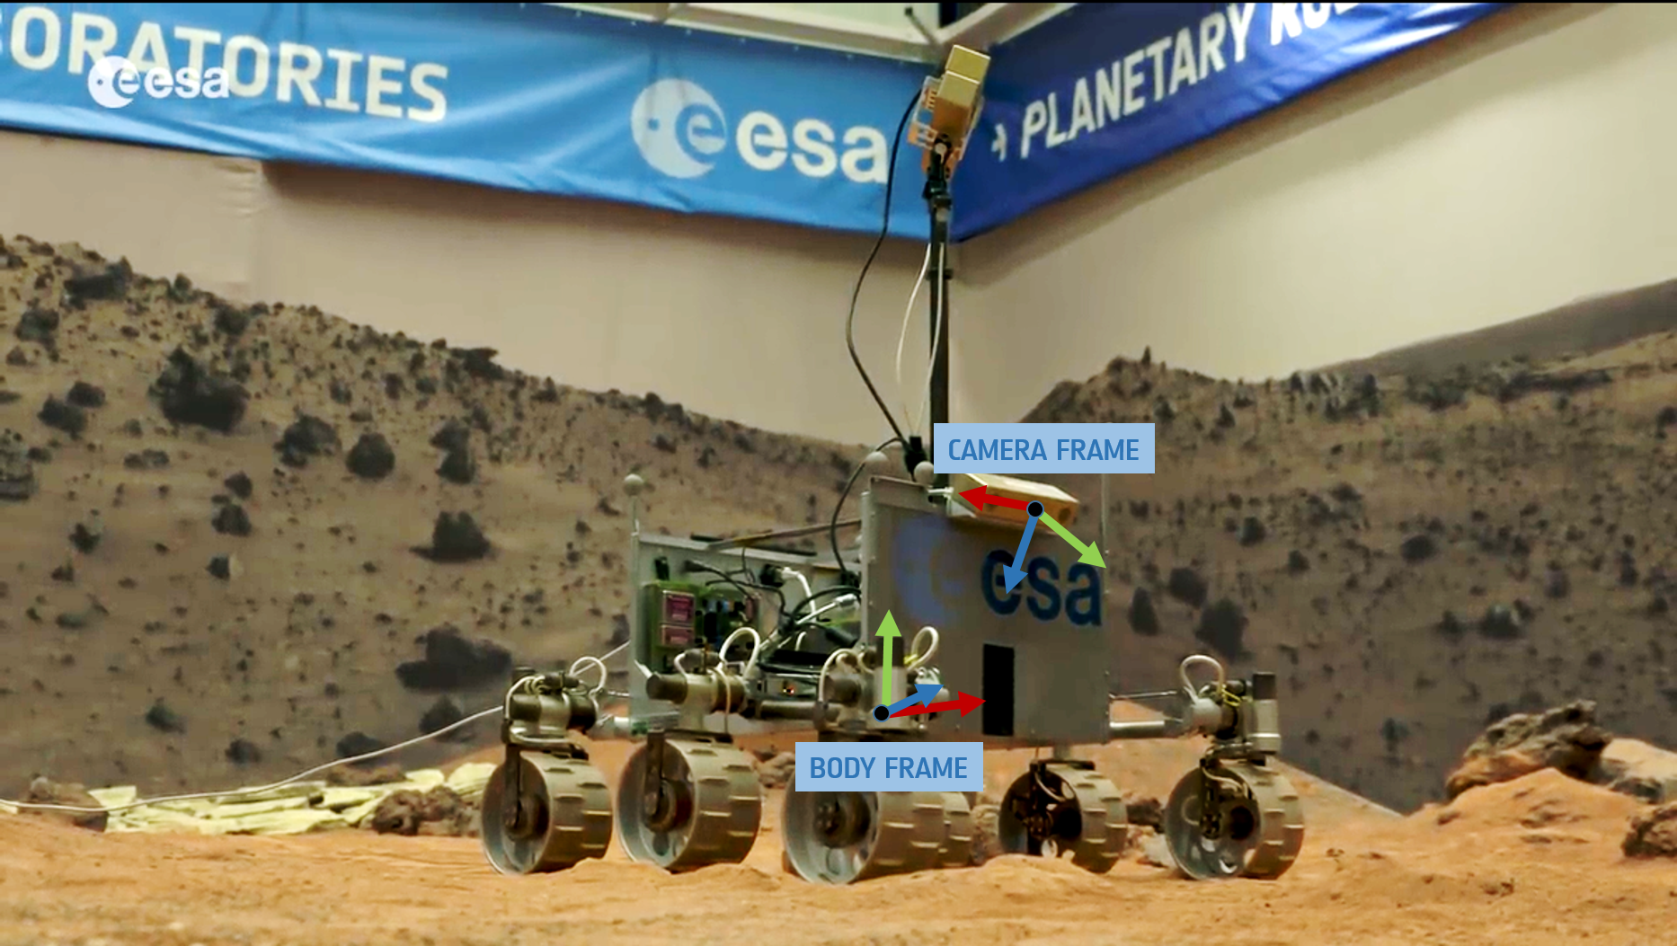

Figure 8: Body and Camera reference frames of the ExoTer Rover

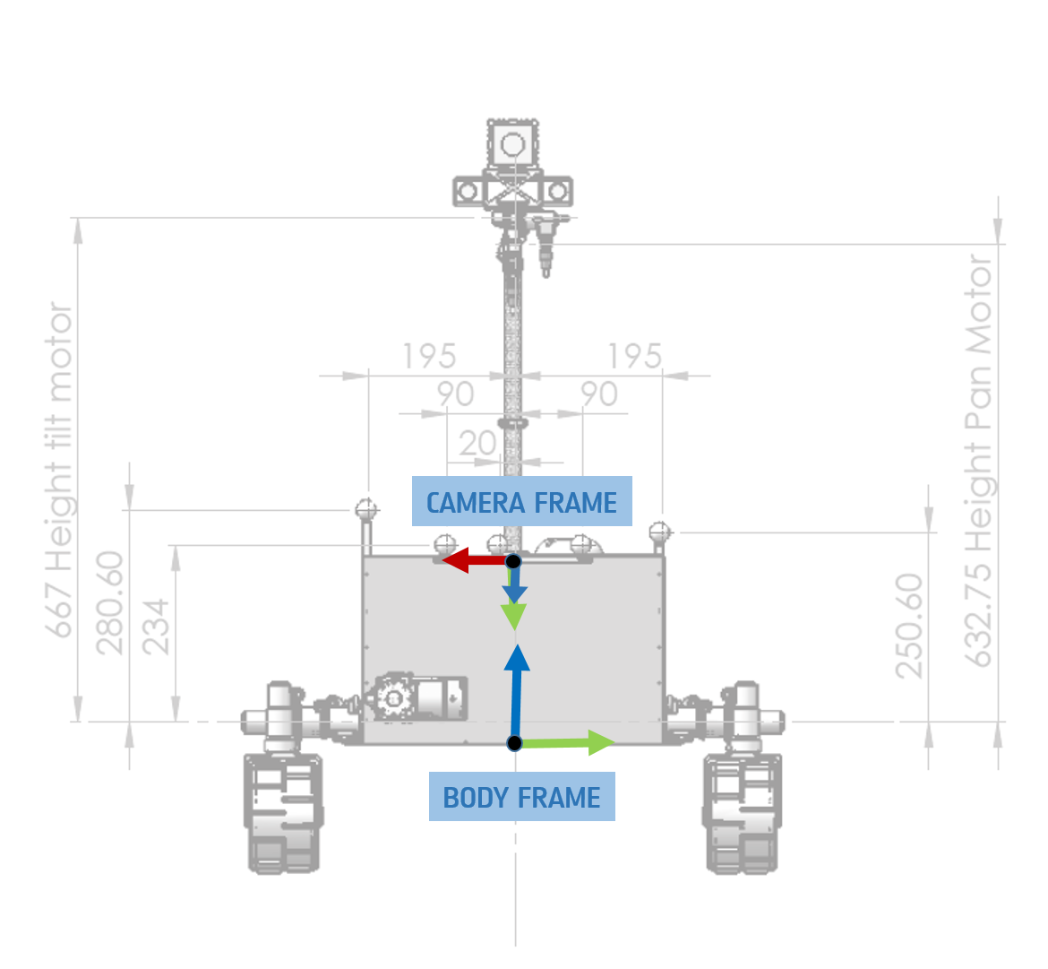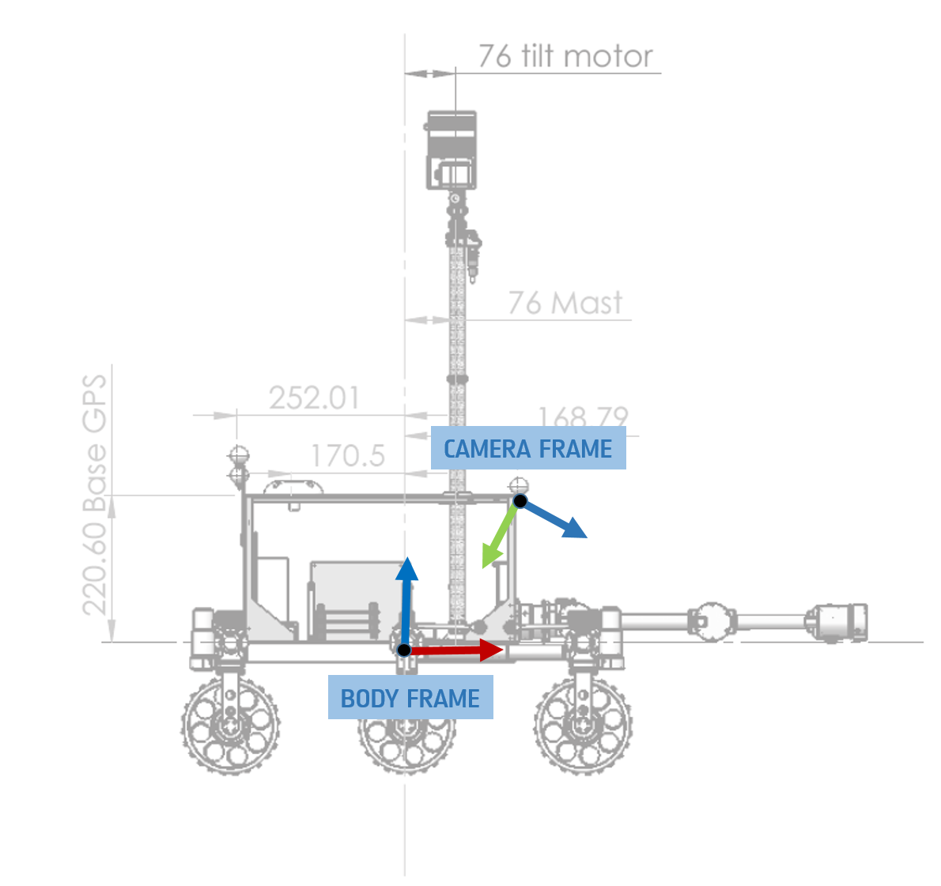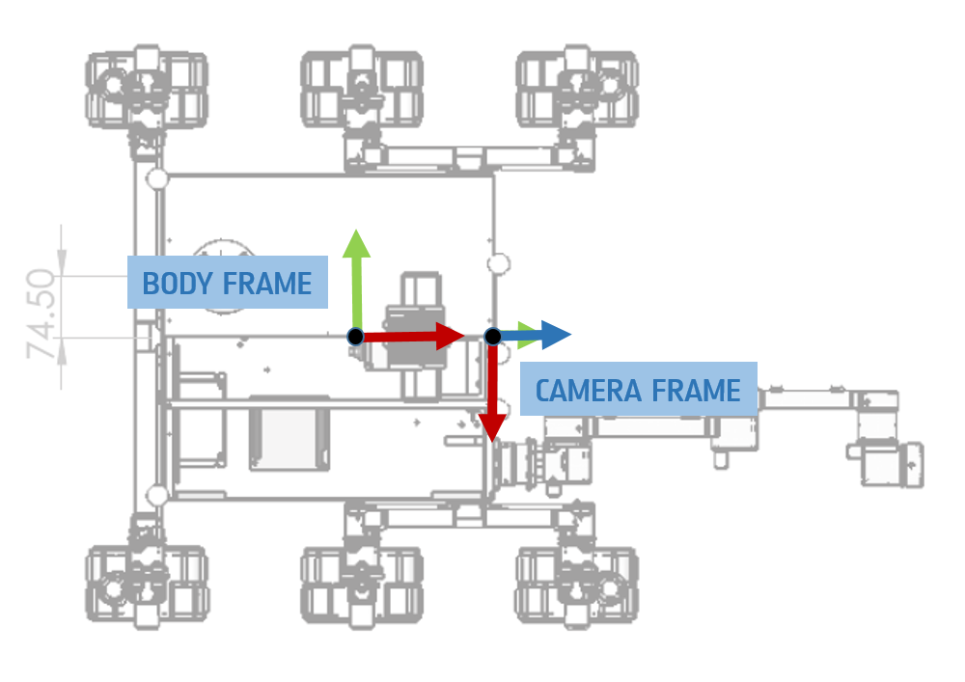

Initially, it was assumed that only the pitch angle may have changed, while the other angles and the position may have not varied significantly with the new mount. The pitch angle was measured using a digital inclinometer and the new value put in the appropriate configuration file.

The performances of the Visual Odometry were then tested and there was no noticeable improvement.

So it was decided to compute the transformation as accurately as possible using the Vicon Tracker system in the lab [RD05].

A total of 4 markers was placed on the camera, where the axis of the camera reference frame are, to be able to place the reference frame in the correct position and orientation.

A script that logs the pose (xyz positions and quaternion) of the camera and the rover was written.

The log is then used in a Matlab script to convert the 2 poses in the single transformation that the configuration file of the Visual Odometry script (xyz positions and Euler ZYX angles).

The new obtained body->camera transformation was very similar to the previous one and, again, did not show improvements in the Visual Odometry performances.

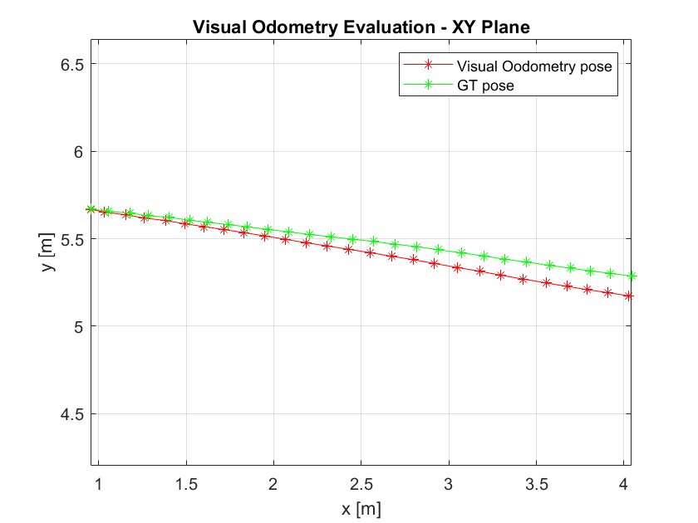

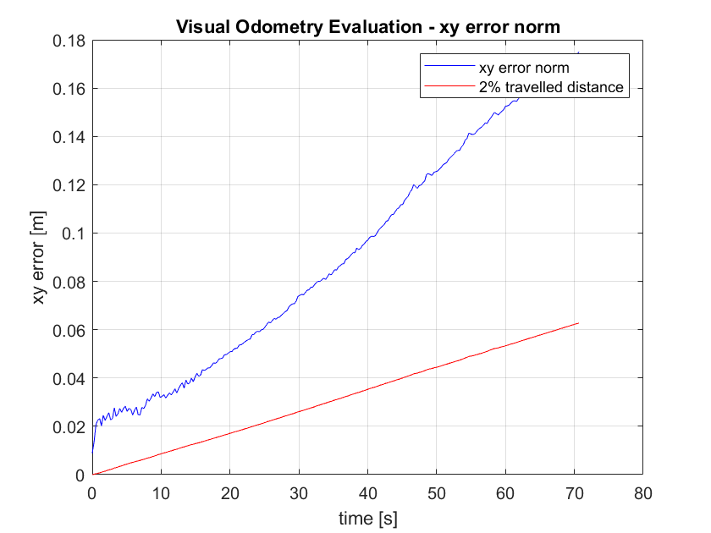

It was also decided to include in the performances analysis an evaluation of the heading angle estimation of the VO versus the ground truth provided by the Vicon system.

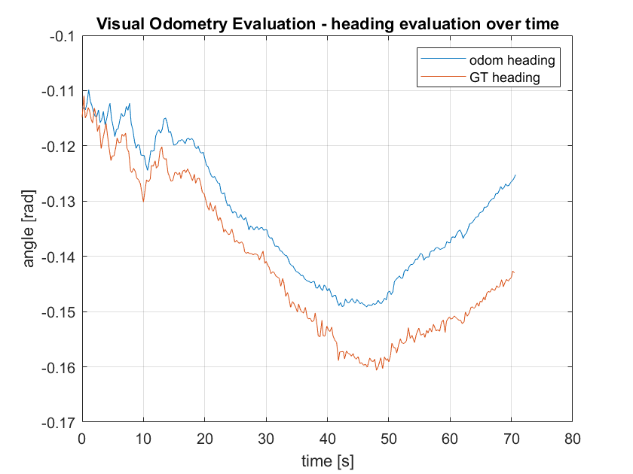

The lack of improvements refining the body->camera transformation led to believe that the problem might instead lie in either the camera intrinsic/extrinsic parameters and/or in the parameters of the VO algorithm implemented in the rover.

The next objective will be to study these parameters and see if any improvement can be achieved.

# References

## Reference documents

|  |  |
| --- | --- |
| Reference | Document |
| [RD01] | ESA PRL GitHub, visodom branch, https://github.com/esa-prl/bundles-exoter/tree/visodom/ |
| [RD02] | Personal GitHub, https://github.com/MatteoDeBenedetti/ESA-Thesis |
| [RD03] | ROCK, Robot Construction Kit, https://www.rock-robotics.org/documentation/index.html |
| [RD04] | Viso2 Library, http://www.cvlibs.net/software/libviso/ |
| [RD05] | Vicon Tracker, https://www.vicon.com/software/tracker/ |

## List of Acronyms

|  |  |
| --- | --- |
| Acronym | Full description |
| ESA | European Space Agency |
| ESTEC | European Space Research and Technology Centre |
| VO | Visual Odometry |
| ARL | Automation and Robotics Laboratories |
| PRL | Planetary Robotics Laboratory |
| ROCK | Robot Construction Kit framework |
| ExoTer | ExoMars Testing Rover |

## Table of Figures

Figure 1: ESTEC 5

Figure 2: Mechanical Department Organization 6

Figure 3: ExoTer Rover 7

Figure 4: ROCK Components 9

Figure 6: ROCK Architecture 9

Figure 7: pose estimation error and z component drift 12

Figure 8: New camera bracket 13

Figure 9: Body and Camera reference frames of the ExoTer Rover 13